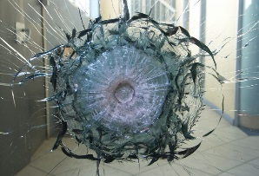
STUDENT SHIELD
STUDENTSHIELD Security Glazing
Laminated safety glass constructed of proprietary transparent materials.
STUDENTSHIELD security glazing is designed to withstand extensive physical
attack (H.P. White 0500.02 Level 1) 25 impacts from a sludge hammer and, also
withstand ballistic protection from small handguns (H.P. White Level A ballistics). STUDENTSHIELD complies with standard safety glazing codes for all interior
and exterior applications.

Testing: H.P White 0500.02 FE, H.P. White Level A Ballistics

Interior specifications:
Weight 4.7 Lbs / sqft
Thickness .5”
Light Transmittance 87%

Exterior specifications:
Weight 7.5 Lbs/ sqft
Thickness 1”
Light Transmittance 73%
U Value .33
Shading Co. .77

All glass should be installed in accordance with the guidelines set forth in the current addition of GANA Glazing and sealant manuals. Patriot Armor recommends no less than ½” bite on all edges. Glazing should be wet glazed on the protected side of the glazing with a high quality structural silicone to promote glazing retention during attack. Product testing has incorporated Dow 995 structural sealant.

100 Valley St. Lee, MA 01238 PH: 413-637-1060 Fax: 413-637-1164

